Home learning Summer Term - Year 3 wc 15th June 2020

Writing
Below are five writing activities for you to do every day. The videos on google classroom
will link to these activities.

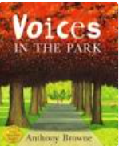
This week the writing will be based on the book: Voices in the Park and you will be writing a 3rd person recount.

Monday 15th June

- Read the story again on this youtube link or the video of Mrs Conway reading: https://www.youtube.com/watch?v=zPqvPL36PfI

- Retell the story to a family member at home – make sure you include all of the information:

The main points of the story are…
Voices in the Park is about…
The key idea is…
This part is about…

- You have some questions to answer about the book:

- Who are the four characters in the book?
- Which is your favourite character and why?
- Can you write a summary of the book using one the following sentence stem?
The main points of the story are…
The Key idea is…
In 10 words…
- Why do you think the mum was annoyed that her son was talking to a girl in the park?
- What do you think the main theme of this story is?

Tuesday 16th June
Today you will be looking at the 4 characters and writing character profiles for them all.
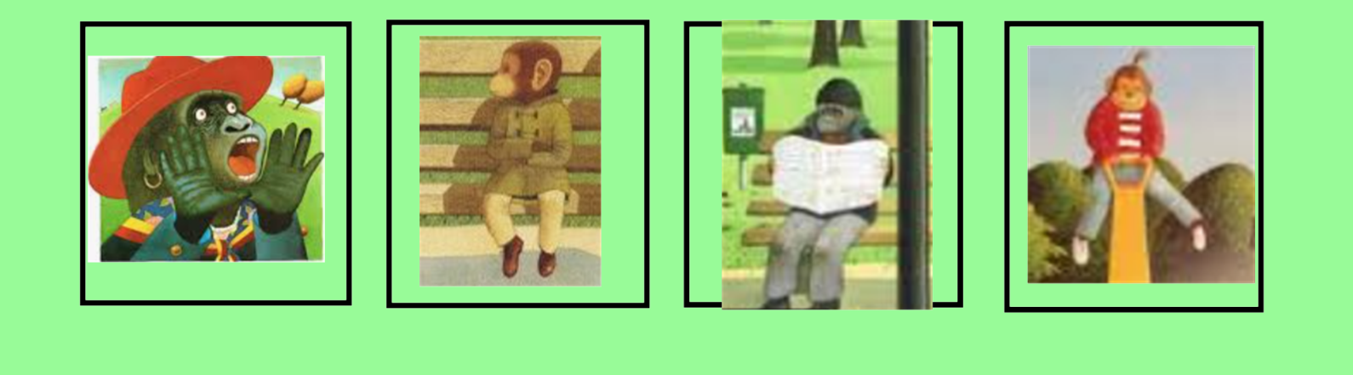

Draw the four characters and write adjectives around their picture to best describe them:
For a challenge, you could also write a paragraph describing each of them.

Wednesday 17th June
On Thursday you will be retelling the story. Today you will be planning the story by creating a story planner.

- What order do the characters talk in?
- What are the characters like?
- Why do you think they are like that?
- What happens in the end?

Thursday 18th June
Today and tomorrow you will be writing a third person recount on The Voices. Today you will write the first half: all about the mum and the dad. Tomorrow you will write the second half.
Remember to use your character profiles and story planner to help you.
Here are sentence stems to help you write the first half:
One day there was a…
The mum was…
It was decided that…
After that…
When they arrived…
The dad was…
He decided to…
He felt…

Friday 19th June
Today you will be writing the second half of your recount. It will be all about the children: Charles and Smudge.
Charles wanted to…
After that…
He liked that…
Smudge was happy to…
Next…
Finally…

Here is an example:
One day there was a grumpy mum, she lived in a large house with a picket fence and a large garden surrounding it. She wore expensive clothes and rarely smiled because she thought she was better than other people.
She decided to take her young son, Charles, and their lively dog to the park. When they got to the park, she noticed a scruffy dog running around which she kept trying to get rid of. She wasn't happy with her dog playing with this scruffy dog so made Charles sit next to her on the bench. Suddenly, she noticed Charles had disappeared and she was horrified. She noticed that he was playing with a 'rough-looking' child and decided they needed to go home at once.

Next there was a dad. A sad-looking dad, who walked with his head down and had little energy. He lived in a dark block of flats with his daughter, Smudge. He decided to take Smudge and their energetic dog for a walk in the park. He sat on the bench in the park and read through the job section in the paper. He had little hope that he would actually get a job though. He didn't notice what Smudge was doing in the park and then decided it was time to go home.

Charles was a bored young boy, he stayed inside a lot and is happy when it's time to go out to the park. He noticed that his dog and another dog were having a great time. He wished he was. All of a sudden, a young girl sat near him on the bench and started to talk to him. He was happy. He was amazed at her sliding down the slide. They played together and everything was alright. He liked her. But mum noticed. She ordered they left and went home immediately. He was sad and hoped he would see her again.

Next there was Smudge, she lived with her dad and she could tell he was sad. She noticed her lovely dog playing with another dog. She was jealous. She started to talk to a boy and thought he was a bit of a wimp but decided to play with him. They both played, laughed and had a lot of fun. She felt really, really happy. Charles gave her a flower which made her really full of happiness. He had to leave the park.
Smudge went home and put the pretty flower in water.

