W/C: 29.06.2020
Africa

This week, our topic is Stories from Other Cultures. We will be focusing on AFRICA.
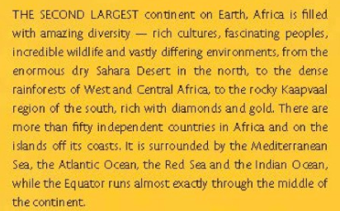
Did you know?

Monday 29th June 2020

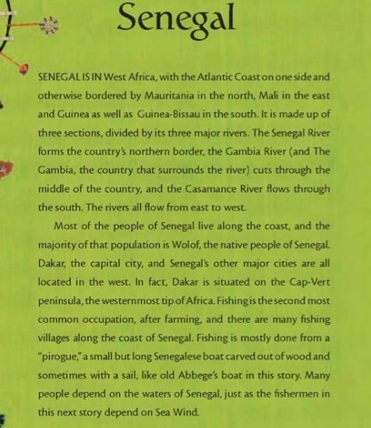
This week’s story is based on an African tale, which comes from Senegal. Read a bit of information about Senegal.

Monday 29th June: Read and infer a story
Task 1: Read the story ‘Sea Wind’ that has been posted under your assignment then write 5 inferences and 5 summaries about the tale, Sea Wind.
I can infer that…
The part _______ makes me think that…
I think that ____ is ___________
I think the setting is_______
The mood is ___________ because _______________

In 10 words or fewer_________
To summarise_________
The main idea is __________
The theme is___________ because__________
The key idea is _____________

Tuesday 30th June: Character description
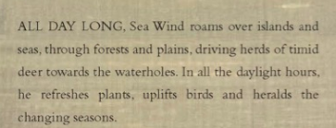
We read all about Sea Wind and the different forms he takes… If we had to illustrate one character for Sea Wind, what would he look like? Use the description below to support. You need to draw the character, label and write a character description.

Paragraph 1: What does Sea Wind look like?
Paragraph 2: What does Sea Wind sound like?
Paragraph 3: How does Sea Wind make others feel?
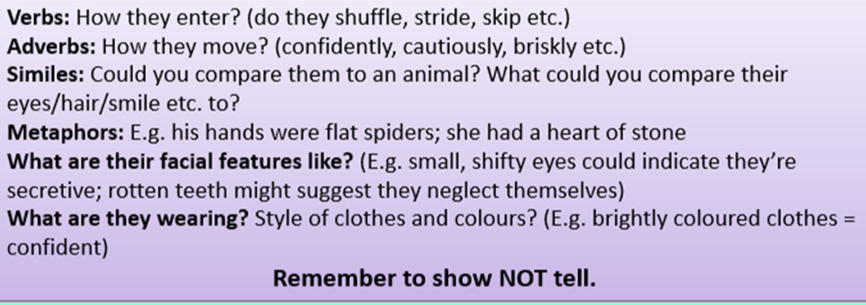

Wednesday 1st July: Setting description
The tale starts with a lovely description of the setting. Use the example below to write your own story setting, describing how Sea Wind moves across the setting.
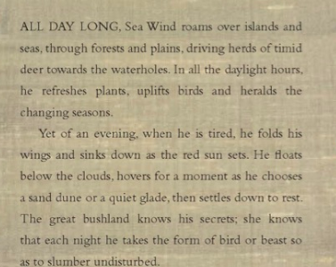

Paragraph 1: What do you hear?
Paragraph 2: What do you see?
Paragraph 3: What do you feel?
Paragraph 4: What can you smell?
Thursday 2nd July: Planning a story
Read the information below about life in Senegal to help you plan a story. Your story must include a magical creature like Sea Wind.
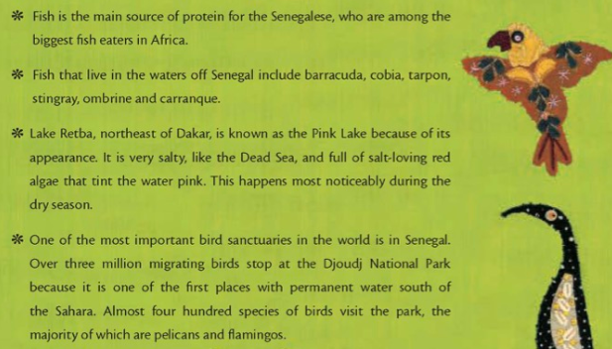

Use the planning template resource to help you.

Beginning: Setting description: Include adjectives, similes and personification

Character: Who is your magical character/creature and what does it do? What are its powers?

Dilemma (problem): Think of a problem that occurs. How do people feel? What has happened?

Resolution: How has your magical character/creature helped to solve the problem? How does the tale end?

Friday 3rd July: Writing a story
Watch the video and use your plan from yesterday to help you write your story.
Include:
- Similes
- Adjectives
- Adverbs
- Speech punctuation
In Lake Retba, where the water shines bright, the wind hums a gentle tune….

