Year One
Children follow the same format as Reception but will work on complex sounds and read books appropriate to their reading level. Daily sessions of RWI phonics last for one hour. Once children become fluent speedy readers they will move on to literacy in Year One and Active English in Year Two.
Five key principles underpin the teaching in all Read Write Inc. sessions:
Purpose – know the purpose of every activity and share it with the children, so they know the one thing they should be thinking about
Participation – ensure every child participates throughout the lesson. Partnership work is fundamental to learning
Praise – ensure children are praised for effort and learning, not ability
Pace – teach at an effective pace and devote every moment to teaching and learning
Passion – be passionate about teaching so children can be engaged emotionally.
Children will be taught how to read as follows:
Before you start to teach your child, practise saying the sounds below. These are the sounds we use to speak in English.
Fred Talk
We use pure sounds (‘m’ not’ muh’,’s’ not ‘suh’, etc.) so that your child will be able to blend the sounds into words more easily.
At school we use a puppet called Fred who is an expert on sounding out words! we call it, ‘Fred Talk’. E.g. m-o-p, c-a-t, m-a-n, sh-o-p, b-l-a-ck.
The following video is an example of blending sounds with Fred. https://www.youtube.com/watch?v=dEzfpod5w_Q
The children are taught the sounds in 3 sets.
Step 1:
Set 1 Sounds are taught in the following order together with rhymes to help children form the letters correctly and instantly recognise sounds ready for blending.

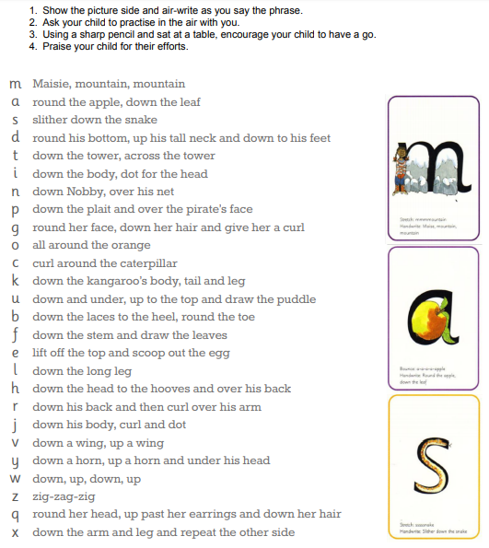

Please do not use letter names at this early stage.
Follow this link to hear how to pronounce the sounds correctly https://www.youtube.com/watch?v=EYx1CyDMZSc

Step 2:
The children are then taught Set 2 Sounds - the long vowels. When they are very confident with all of set 1 and 2 they are taught Set 3 Sounds.
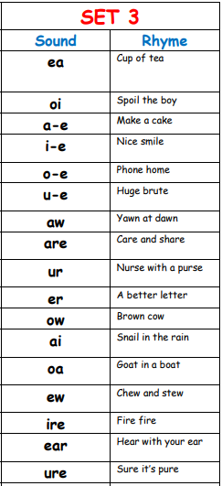
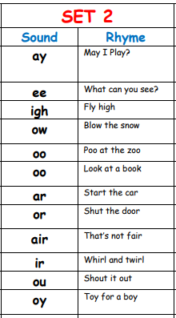

Nonsense words (Alien words)
As well as learning to read and blend real words children will have plenty of opportunities to apply their sound recognition skills on reading ‘Nonsense words’. These words will also feature heavily in the Year One Phonics Screening check in the summer term. Click here for further information on the Screening check.
Step 3:
Children will be introduced to ‘Ditty books’ when they successfully begin to read single words. The short vowels should be kept short and sharp:
Children use sound-blending (Fred Talk) to read short ditties. Children will then be challenged to use their developing phonic knowledge to write short sentences.
Within all the books children will have red and green words to learn to help them to become speedy readers. Red words are words that are not easily decodable and challenge words to extend children’s vocabulary. Green words are linked to the sounds they have been learning and are easily decodable.
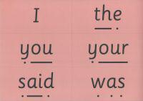
Dots and dashes represent the sound each letter makes.
During the RWI session children will read the book and at each new reading they will have plenty of opportunities to practise using their developing comprehension skills. You may have heard your child talking about ‘hold, edit or build a sentence’.
Hold a sentence is an activity that encourages children to remember a whole sentence while focusing on spelling and punctuation.
Build a sentence is to give children the opportunity to create their own sentence to that shows the meaning of a word and edit a sentence allows the children to critique a sentence using their knowledge of spelling punctuation and grammar. Children complete a longer piece of independent writing, which gives them the opportunity to show off their creativity and to practice their spelling, grammar and punctuation.
To help at home:
Your child will start to bring books home when they are confident readers. Please help them to read and give lots of praise!
If you have any other questions about RWI, please see your class teacher or see Mrs Khanna.
Phonics Screening Check Year One
What is the Year 1 phonics screening check?
The Year 1 phonics screening check is a short, light-touch assessment to confirm whether individual pupils have learnt phonic decoding to an appropriate standard.
It will identify the children who need extra help so they are given support by their school to improve their reading skills. They will then be able to retake the check so that schools can track pupils until they are able to decode.
Further information can be found here.

Useful websites for Parents
Please find a list of websites that you may find useful in helping you and your child learn about phonics. Games and fun activity websites are also included.
http://jollylearning.co.uk/ - Games and information for parents
http://www.phonicsplay.co.uk/ - many games to play
http://www.bbc.co.uk/bitesize/ks1/literacy/phonics/play/ - fun games for the children to play
http://www.ictgames.com/literacy.html - fun games for the children to play
http://www.kenttrustweb.org.uk/kentict/kentict_home.cfm - fun games for the children to play and information for parents
http://www.ngfl-cymru.org.uk/ - fun games for the children to play

