Narrative Poetry
A narrative poem is a longer form of poetry that tells an entire story, with a beginning, middle, and end. Narrative poems contain all of the elements of a fully developed story, including characters, plot, conflict, and resolution. These poems are typically told by just one narrator or speaker.
Task 1
On the next page are two narrative poems. What features can you see? As well as poetic features, where is the beginning, middle and end? How do the poems make you feel and how has the author achieved that? Note the PAG. How is it different to a normal narrative? As you read it is the PAG guiding you to read in a certain way?

You can write some notes/examples of features under the title of each poem in your work book.

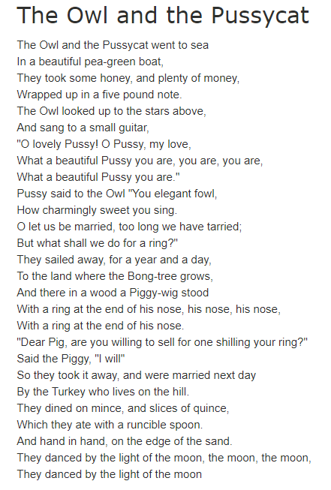
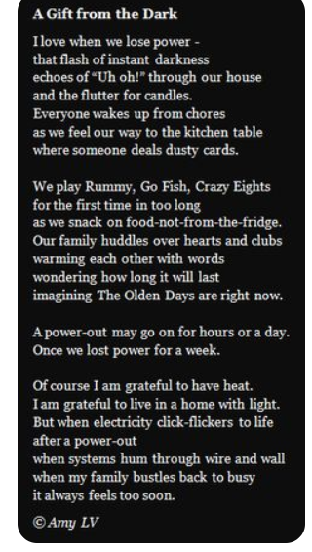

Task 2
Linking our poetry to our ‘Scary and Suspense’ writing we are going to plan and write a narrative poem based on a spooky tale.
If you have read Skellig, perfect, if not then here is a summary…
Skellig - When Michael moves into a crumbling, old house with an ancient garage that he cannot resist going into, he encounters a mysterious creature named Skellig. Slowly they come to trust and care for each other and help each other through the most difficult phase of their lives.
Now, your character (Michael) can be any age. He lives with his mum, dad and baby sister (she is not old enough to talk – so perhaps he tells her tales of Skellig when his parents aren’t around).

In your poem think about Michael visiting the garage when he has just discovered Skellig. How is he feeling?

Use the following sub-headings in your workbook to plan your poem. In every section you must include: repetition, speech, onomatopoeia, emotive language and try to add some similes and metaphors too. Remember your poem does not have to rhyme, it has to tell a story.

Characters (ages, jobs, relationships)

Setting description (describe the garage, are there cobwebs as thick as custard?!)

Main Body (What happens? What can Michael see/hear/taste/feel/smell? How do Skellig and Michael interact? Michael must still be wary of this creature yet intrigued).

Ending (how does your poem end, does Michael need to go back for dinner? Does he promise to return as soon as possible? Do they make some sort of pact?
Task 3
Write your poem. Remember to use repetition, speech, onomatopoeia, emotive language, similes and metaphors. If you can add any other features, please do. Look over the two poems we read in task 1 and your plan before you begin to write.
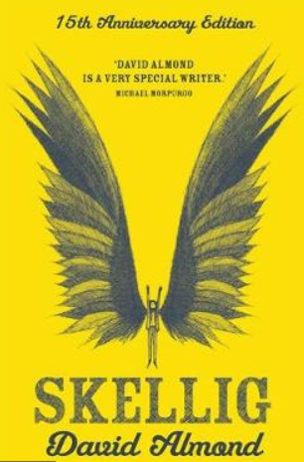
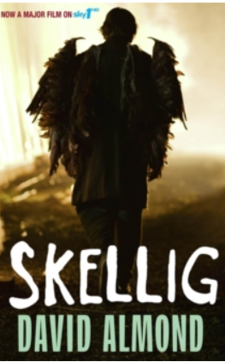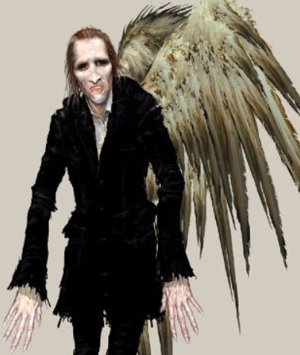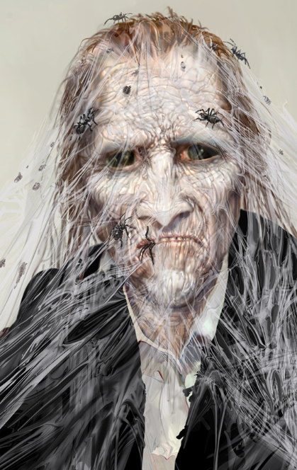
What do you think of the start of my poem? What features have I used? How does it make you feel? You can use some if my ideas but, as always, please do not copy.

“Just off to the garage!” Michael yelled as he tugged on his grey, battered boots.
His stomach was a mass of knots and butterflies.
His throat: dry - as dry as a desert.
The garage looked peaceful as the sun shone on it.
Michael’s hands trembled. Trembled. Trembled.
He reached for the door, his nose filled with a musty smell.
Crrreeeaaakkkkkkkk.
The garage was empty and calm.
Shafts of sunlight crept in the cracks of the covered windows.
He waited, waited, waited…until he heard it.
The swoop of a wing above his head.
It was here. As promised.
Task 4
On a new day, with fresh eyes, please read your work through and edit it. Get a dictionary and thesaurus. If there is an adult available read it through with them and ask for some feedback.

Task 5
A Year 6 objective is to remember poetry by heart and perform confidently. Are you brave enough to perform your poem for your family at home? If so, can you memorise chunks and have you paper handy just in case? Challenge yourself, how much can you remember?

If you do not want to perform to your family, perform to yourself, or an audience of stuffed animals! Performing is not easy and we have done a lot of it in Year 6. Everything is always different when you speak in front of others, nerves kick in and it never quite goes how you think it will. You have all become so much better at talking in front of your peers. Challenge yourself and read your poems aloud. Those of you with younger sibling have the toughest job. I wonder if you can keep them entertained…

I think (sorry if I am wrong!) Skellig is on Netflix. The age rating is 11+ so check and watch it with an adult if they think it is appropriate.

We hope you are all well Year 6. Keep working and make sure you are drinking water, resting and not spending too much time on your video games!

