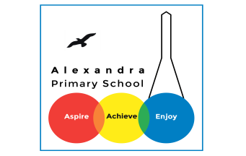
Home learning Summer Term Week 1 Year 3
Writing
Below are two writing activities for you to do this week.
Make sure you write at least a page for each piece.
Recount
Watch this video on The Literacy Shed website.
https://www.literacyshed.com/thewaybackhome.html

Can you recount what happens in the story? Use this planning sheet to help you.
Remember to use a new paragraph for each section.
One day, a curious boy was looking in a dusty, old shed in his garden and he found a rocket.
Character description
In Spring 1, we looked at creatures from Myth and Legend stories. Look at these pictures of different mythical creatures. Can you make up your own mythical creature?
What will their body be like? What will their head by like? What will their face be like?
Are they good or bad? What magic powers do they have?
Draw a picture of your mythical creature and write a character description.
Please write two paragraphs: one about what they look like and one about what their personality is like.
You can look at the writing below to get ideas and also look at the box of phrases – can you use some of them in your writing?
Hyenath
Hyenath is a strange creature – part hyena, part human and part eagle. She has the body of a hyena, the head of a human and the wings of an eagle. Her feathered wings are huge, her body is covered in slimy, brown fur and her head is dominated by enormous, eyes which glow red when she is angry.
Hyenath is evil through and through. When you see Hyenath, your blood will run cold. She sees your fear and this gives her even more courage. She is dark-hearted and will never show kindness except to her daughter, Hyenathea, who she loves with all her heart. With Hyenathea, she will laugh and sing and, sometimes, she will even dance in the skies, her broad wings carrying her high in the sky with her daughter next to her.
Phrases – adjectives and nouns
half-human, half hyena
part ape, part scorpion
slimy green body of a lizard and the head of a badger
hideous, red creature with eight legs
the head of a fly and a snake for a tail
venomous, serpentine creature
huge, rounded-bodied raven
human above the waist,a leopard below and an enormous shell on its back
colossal, eight-foot camel
narrow body of a wolf

