Maths Home Learning Year 3
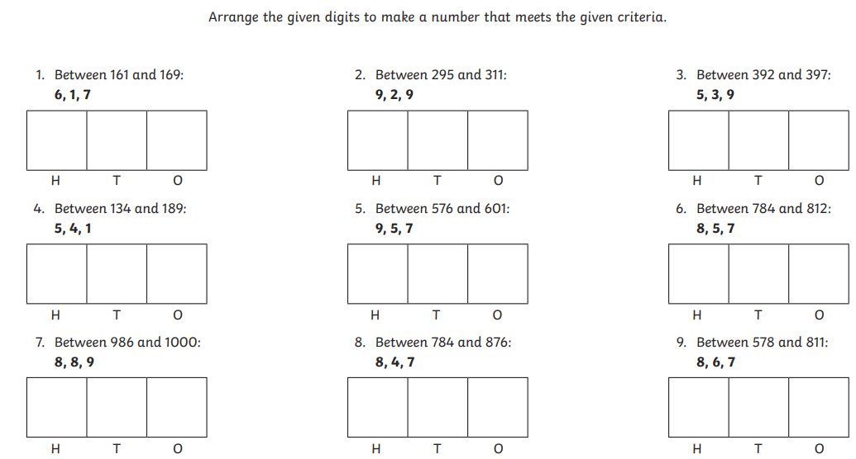
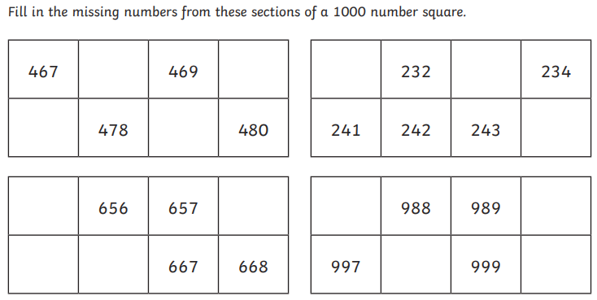
Place Value - Summer 2-20.04.2020
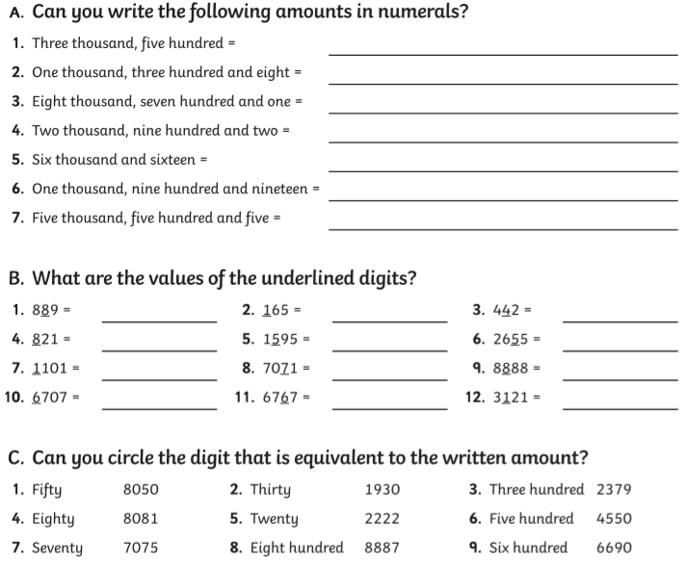

Maths- No Problem
Worksheet 2- Pages 3-4
Worksheet 3- pages 5-6

Purple Mash
New learning has been set on you on Purple Mash also.

TT Rockstars
New learning has been set on TT Rockstars! Get practising on here!

