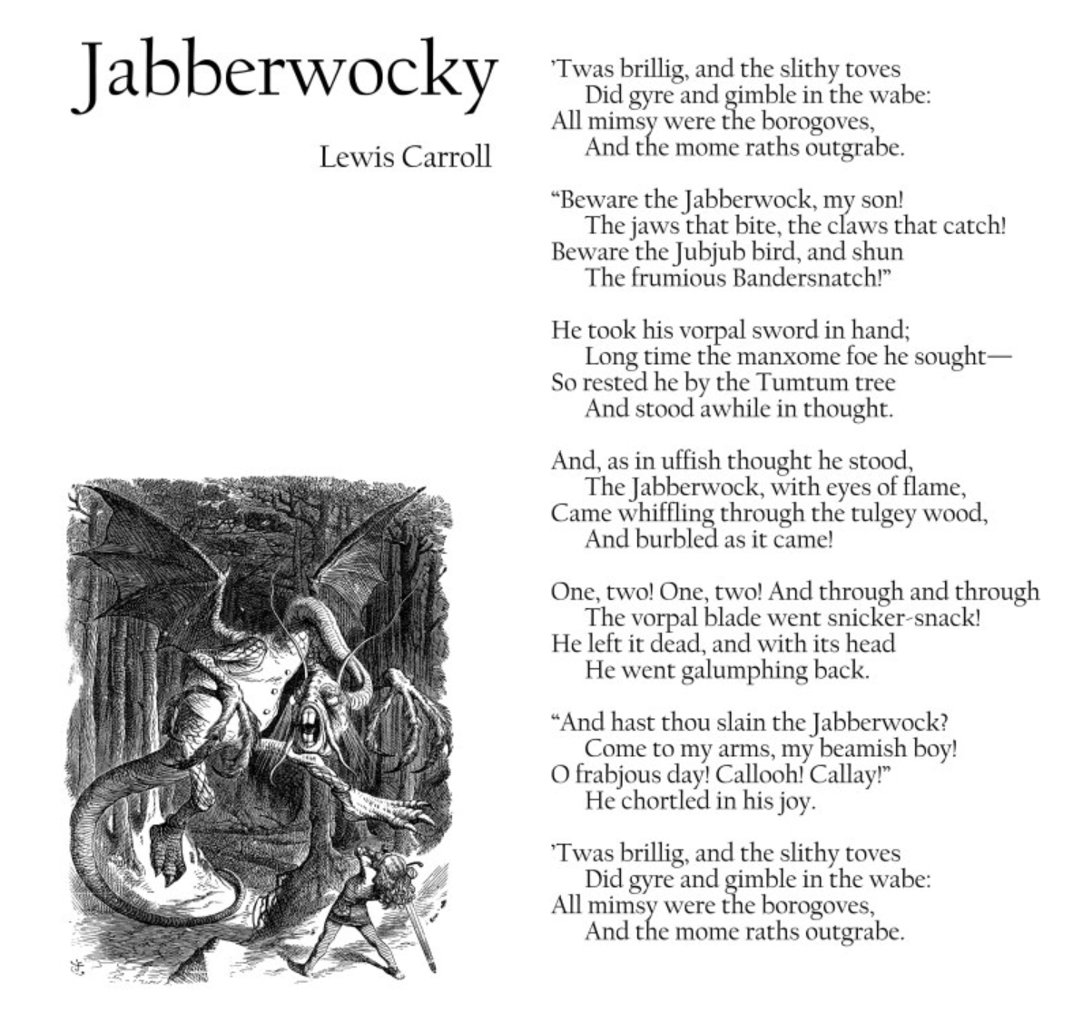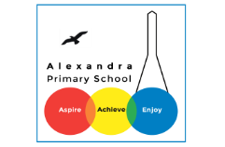

**Home Learning – Week 3 - English**

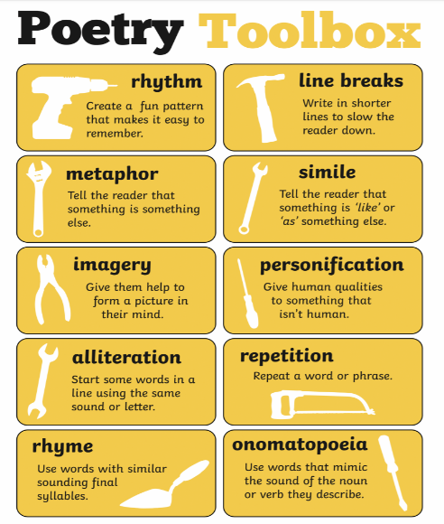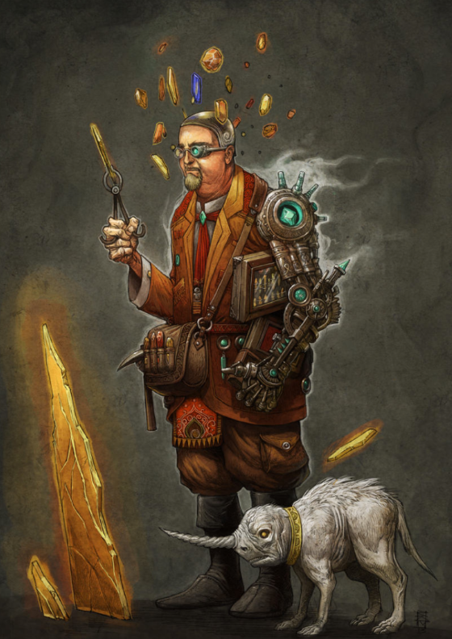

**Task 1: Nonsense Poems**

Using your own made up

Words write your own

Nonsense poem like Lewis

Carroll’s Jabberwocky.

**Task 2: Write a short story**

**based on this character.**

