Home Learning Year 1
Week beginning Monday 30th March 2020
Maths
This week our focus times table is: 10 x table
Practise saying and writing the 10x table and when you can do it in order, see if you can remember facts in any order (eg. 3 x 10 = , 9 x 10 = etc)
Purple Mash – Speed test 10x table – How many correct answers can you get before the time runs out?
https://www.purplemash.com/#app/games/tabletoons/Speedtest_10x

This week we will be looking at position and direction
Practise turning your body full turns, half turns, quarter turns and 3 quarter turns. What do you notice about where you end up after each kind of turn?
Games idea : Play Simon Says (eg Simon Says do a half turn).
quarter turn | half turn | three quarter turn | full turn
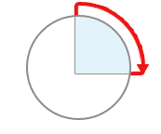 | 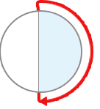 | 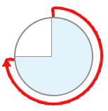
Purple Mash - 2Go – can you use your knowledge of direction to complete the maze?
https://www.purplemash.com/#app/tools/2go
Maths No Problem book - page 85 – focusing on position (1st, 2nd, 3rd etc)

We will also be practicing our addition.
Copy these questions and solve them in your maths home learning book.
Tips to help you add:
- you can put the first number in your head and count on the second number
- you can use practical resources like bits of lego, coins, pencils (anything really) to help you count out the correct numbers and then count them all together
- you can swap the numbers so that you are starting with the bigger number
eg. 4 + 7 = instead of starting at 4 and counting on 7 you can do 7+4 = and start with 7 then count on 4. The answer will be the same!
- you can use a numberline like the one below (copy it into your book)
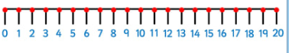
3 + 4 = | 6 + 2 = | 5 + 3 =
9 + 4 = | 5 + 7 = | 3 + 9 =
6 + 8 = | 4 + 8 = | 7 + 7 =
7 + 4 = | 6 + 7 = | 8 + 5 =
8 + 7 = | 9 + 8 = | 6 + 5 =

Challenge!
Can you work out the missing number?
