Maths Home Learning Year 3
Pictogram
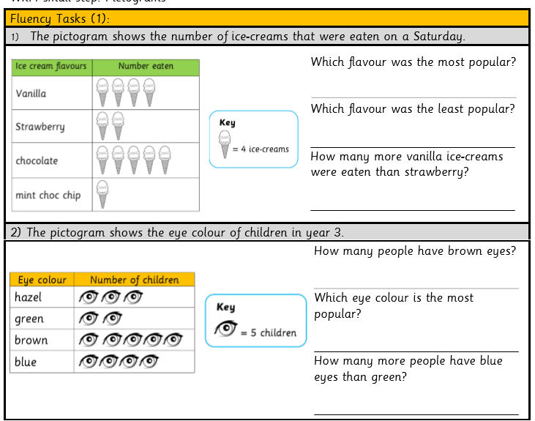
wc 30.03.2020

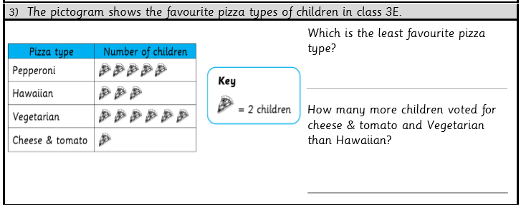

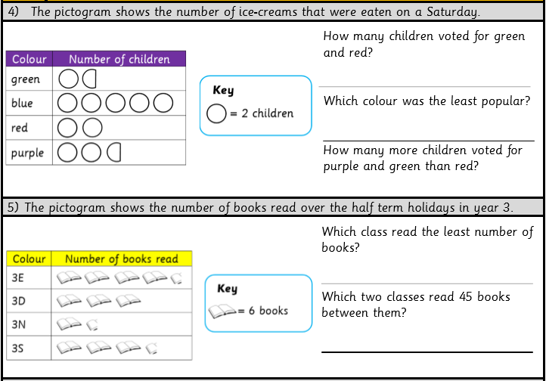

Purple Mash
New learning has been set on you on Purple Mash also.
TT Rockstars
New learning has been set on TT Rockstars! Get practising on here!

