Task 1: Log in to Purple Mash:
- Math Task: Problem Solving (4 Operations)
- Math Game: Multiplication
Task 2: Log on to Rockstars and test yourself. Below is also a paper version.
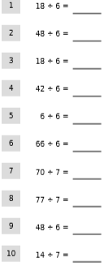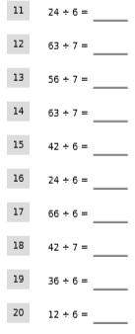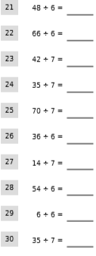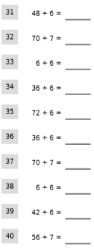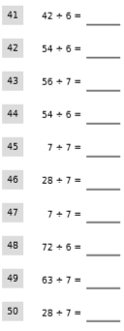

Task 3: Use your knowledge of place value to compare and order numbers. Justify your reasoning.
1. Jane is asked to write some numbers in order from least to greatest.
Here is her solution:
4 427 123, 4 472 123, 4 197
Is she correct or incorrect? Justify.
_________________________________________________________________________________________________________________________________________________________
2. Use these inequality symbols $<=≠>$ only once to compare these numbers.

1 098 823 1 097 945

1 355 823 1 355 823

7 215 703 7 214 704

5 411 522 5 411 529

3. Two football team are comparing the number of fans who attended their stadium last season. The attendance at Emirates was 1 670 234 fans. The attendance at Old Trafford was 1 680 234 fans.
Which team had more fans at their stadium? Explain why.

Task 4: Use your knowledge of the 4 operations to work out the following questions:
