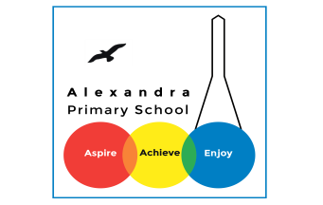
Home learning
Spellings
Pick 5 words to practise every day. Choose an activity to help you to remember them.
Spelling activities:
- Look, cover, write, check
- Dot and dash
- Write the meaning of the word
- Write the word within a sentence
Below are the spellings for Years 1 and 2
