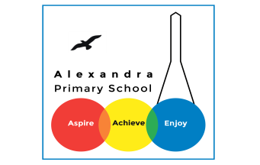
Home learning wc ___________
Reading
Below are some activities you can use when learning at home. We would expect you to write at least a page worth for each piece. You should be reading for 30 minutes each day.
1

https://www.getepic.com/
Go the following website to read a text of your choice. Using your Destination Reader stems, record three strategies a day.
Name of Book:
Date:

Prediction

Inference

Summary
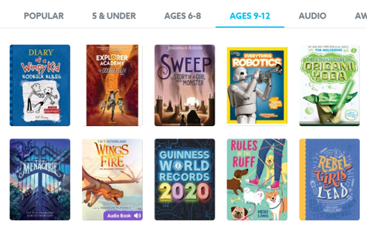

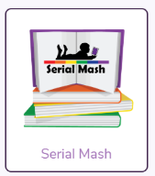
2
Log on to purple mash . Then go to ‘Serial Mash’. -

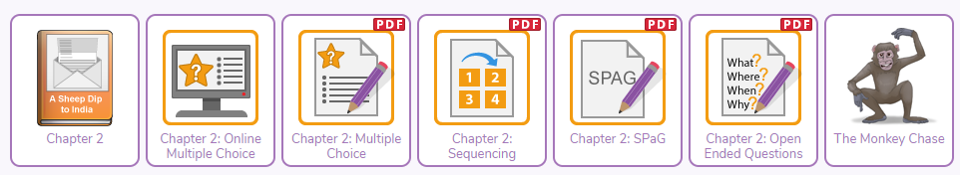
Once you are on serial mash, you can choose a text for your age group and answer the following questions.

3
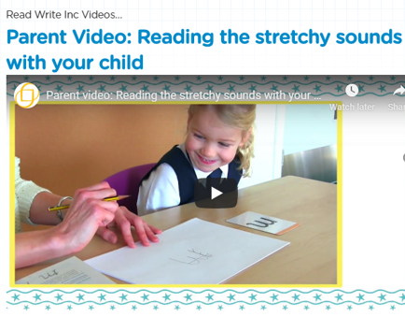
Phonics: Please see our website for some useful links in practising phonics with your child.

www.alexandraprimaryschool.co.uk
