MATHS HOMEWORK 27/03/2020
- Column addition
The column method is a mathematical method of calculation where the numbers to be added or subtracted are set out above one another in columns.

The calculation is done by ‘carrying’ and ‘borrowing’ numbers from column to column.

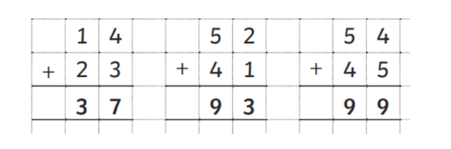

- Column Subtraction
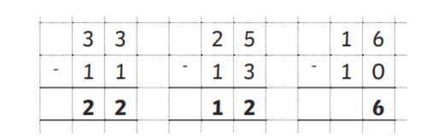
The column method is a quick way for a child to work out addition and subtraction but place value needs to be learnt.
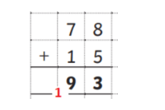
The 7 in the above equation is not a 7 but in fact is a 70 and the 1 is a 10.
A child needs to add the tens first: 70+10 = 80
Then add the units: 8+5 = 13
Finally add the two answers together to get 93.

The column method involving carrying numbers is the quickest method for a child once they understand place value and they have the ability to mentally add and subtract multiples of ten and one hundred.
- Column addition calculations to solve:
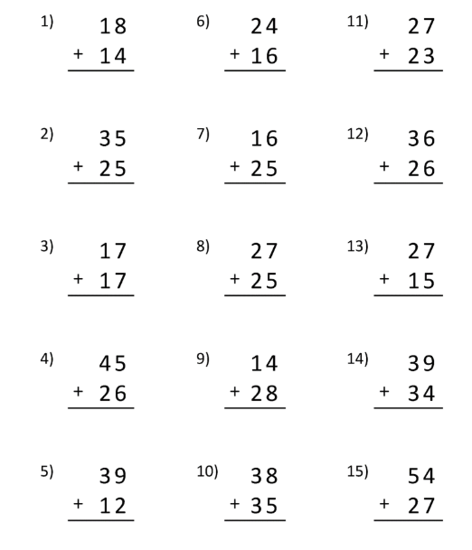

- Column subtraction calculations to solve:
