Home learning week 1
Writing
Below are some activities you can use when learning at home.
We expect you to write 3 pieces of writing a week.
Make sure you write at least a page worth for each piece.
1
2
Story writing
Continue this story.

I went flying through the air and hit the ground with a loud thump. I stood up and looked around at the strange surroundings. This was not home…

Diary Entry
Write a diary entry on what is happening in the news with the coronavirus.
How did it start?
What is happening?
What are the politicians saying about it?
How do you feel about it?
What do you think will happen next?

3

Setting description
Here is a sentence starter, write a setting description from this sentence.

In front of me was a long tunnel of trees, I kept walking to find out more…

Home learning week 2
Writing
Below are some activities you can use when learning at home.
We expect you to write 3 pieces of writing a week.
Make sure you write at least a page worth for each piece.
Instructions

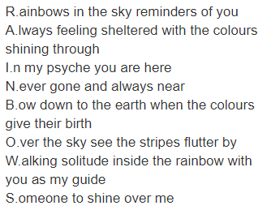
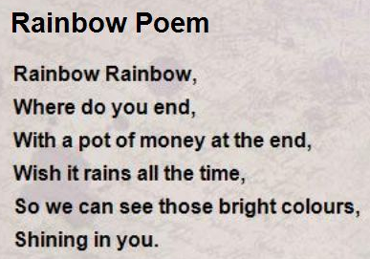
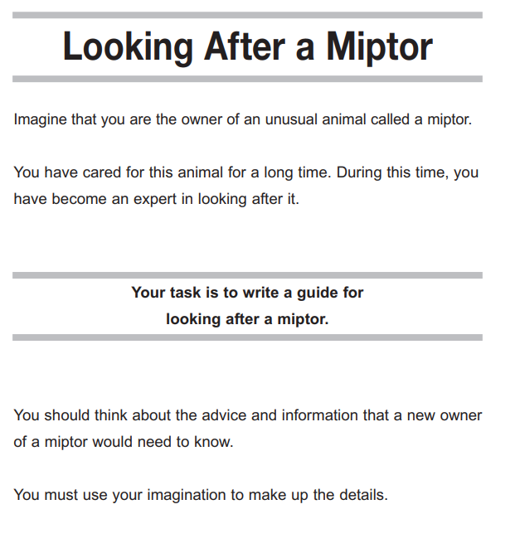
Character description
Imagine your own superhero. What do they look like?
What super powers do they have?
Do they have a day job?
What do they enjoy to do?
Are they good or bad?

Draw a picture of your superhero and write a character description.

Examples of poems:
Poetry
Write a poem based on this image.
You could include: adjectives, rhyming words, alliteration, onomatopoeia, figurative language.

