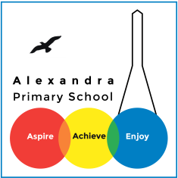
Alexandra Primary
Term & Holiday Dates 2018/2019
Autumn 2018
Monday 3rd September 2018 – Friday 19th October 2018 35 days
(Half term Monday 22nd October 2018 – Friday 26th October 2018)
Monday 29th October 2018 – Friday 21st December 2018 40 days
(Holiday Monday 24th December 2018 – Friday 4th January 2019)
Spring 2019
Monday 7th January 2019 – Friday 15th February 2019 30 days
(Half term Monday 18th February 2019 – Friday 22nd February 2019)
Monday 25th February 2019 – Friday 5th April 2019 30 days
(Holiday Monday 8th April 2019 – Monday 22nd April 2019)
Summer 2018
Tuesday 23rd April 2019 – Friday 24th May 2019 23 days
(Bank Holiday Monday 6th May 2019)
(Half term Monday 27th May 2019 – Friday 31st May 2019)
Monday 3rd June 2019 – Tuesday 23rd July 2019 37 days
Teacher Availability Days – The school is closed on these days
Monday 3rd September 2018
Tuesday 4th September 2018
Tuesday 23rd April 2019
Monday 22nd July 2019
Tuesday 23rd July 2019 Total 195 Days

